OOP 2nd Assignment
BY
MD.Junayed Bin Karim
I’D:0242220005101667
Display Some information in Java
1. Print “Hello Class” in JAVA.
2. Print Multiple Lines.
3. Add two integers and print the result.
1. Print Your Information (Name, ID, Address, department, favorite game etc).
2. Initialize a variable with your name and then print it.
3. Find the area of a Circle.

1 Print "Hello Class" in JAVA:
public class HelloWorld {
public static void main(String[] args) {
System.out.println("Hello Class");
}
}
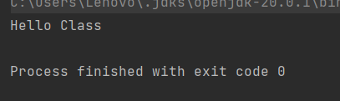
2 Print Multiple Lines:
public class PrintMultipleLines {
public static void main(String[] args) {
System.out.println("Line 1");
System.out.println("Line 2");
System.out.println("Line 3");
}
}

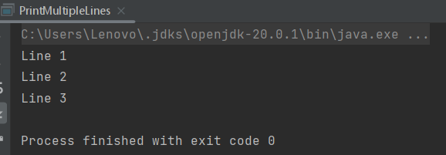
3 Add two integers and print the result:
public class AddTwoIntegers {
public static void main(String[] args) {
int num1 = 10;
int num2 = 20;
int sum = num1 + num2;
System.out.println("The sum of " + num1 + " and " + num2 + " is: " + sum);
}
}
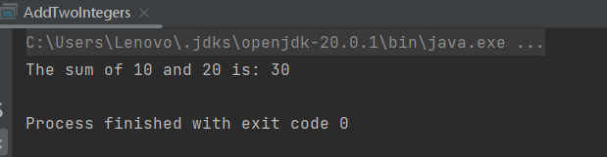
- Print Your Information (Name, ID, Address, Department, Favorite Game, etc.):
public class MyInformation {
public static void main(String[] args) {
String name = "Junayed Bin Karim";
int id = 1667;
String address = "Savar, Dhaka";
String department = "CSE";
String favoriteGame = "Chess";

System.out.println("Name: " + name);
System.out.println("ID: " + id);
System.out.println("Address: " + address);
System.out.println("Department: " + department);
System.out.println("Favorite Game: " + favoriteGame);
}
}
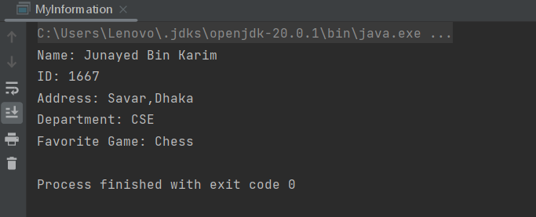
2 Initialize a variable with your name and then print it:
public class PrintName {
public static void main(String[] args) {
String myName = "Junayed Bin Karim";
System.out.println("My name is: " + myName);
}
}
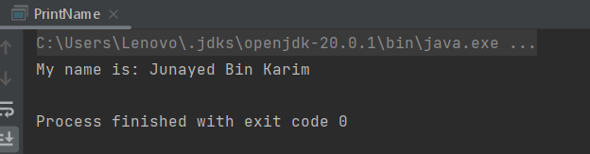
3 Find the area of a Circle:
public class CircleArea {
public static void main(String[] args) {
double radius = 5.0;
double pi = 3.14159;
double area = pi * radius * radius;
System.out.println("The area of the circle with radius " + radius + " is: " + area);
}
}
